**Project**

* Selection / Toggle between teleporting and walking

**Navigation_Type**

**Walking (W)**

* Toggle between subtypes
* Two Subtypes
  + Walking with physical movement in a given space
  + Walking without physical movement (stationary)

**Teleporting (T)**

* Toggle between subtypes
* Two Subtypes
  + Teleporting (instant change of location)
  + Jumping (change of location in an arch)

**Navigation_Subtype**

**Physical Movement (W)**

* Toggle between methods
* Three methods
  + Normal Walking
  + Scaled Walking
  + Dynamic Walking

**Stationary Movement (W)**

* Toggle between methods
* Two methods
  + Walking in Place (with hand movement)
  + Walking by Leaning

**Teleporting (T)**

* Toggle between methods
* One method
  + Teleporting

**Jumping (T)**

* Toggle between methods
* One method
  + Teleporting

**Navigation_Method**

**Normal Walking (W)**

* Unchanged walking method

**Scaled Walking (W)**

* Normal walking with scaled movement speed
  + Scaled unit vector of the perspektive
  + Movement in other directions unchanged
  + Eventual with Trigger on Grid Button

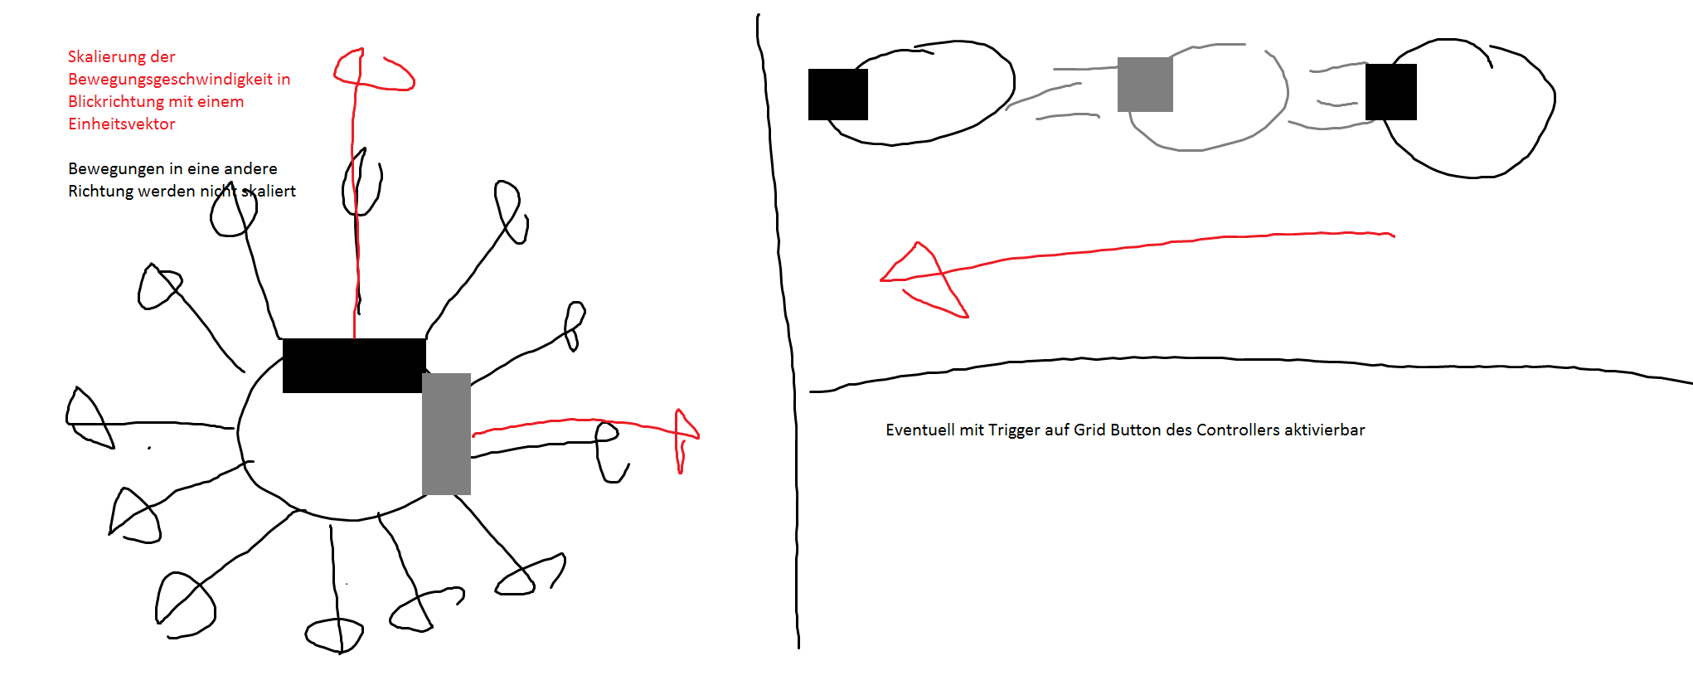

**Dynamic Walking (W)**

* Normal walking with scaled movement speed
  + When walking towards an

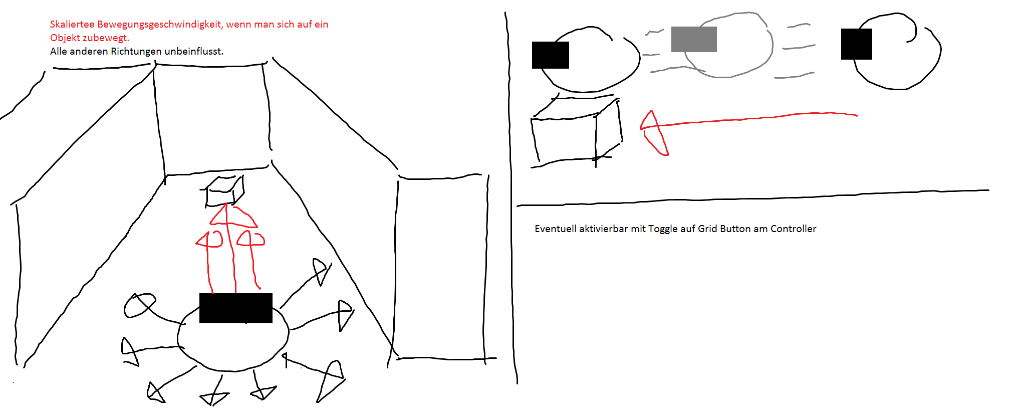

**Walking in Place (W)**

* Walking in the virtual space by moving the controllers
  + “Walking” Movement (Moving Controllers Forward and backwards)
  + Faster hand movement equals fester Walking Speed?
  + Walking in the direction one is looking.

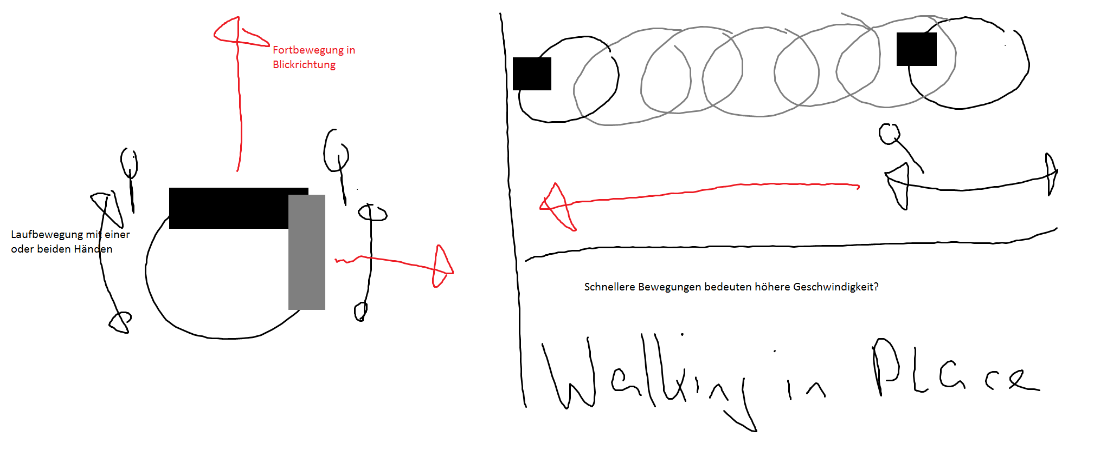

**Walking by Leaning (W)**

* Walking by leaning into the direction you want to walk
  + Fix movespeed
  + If leaning more than ~30° (Movement trigger threshold)

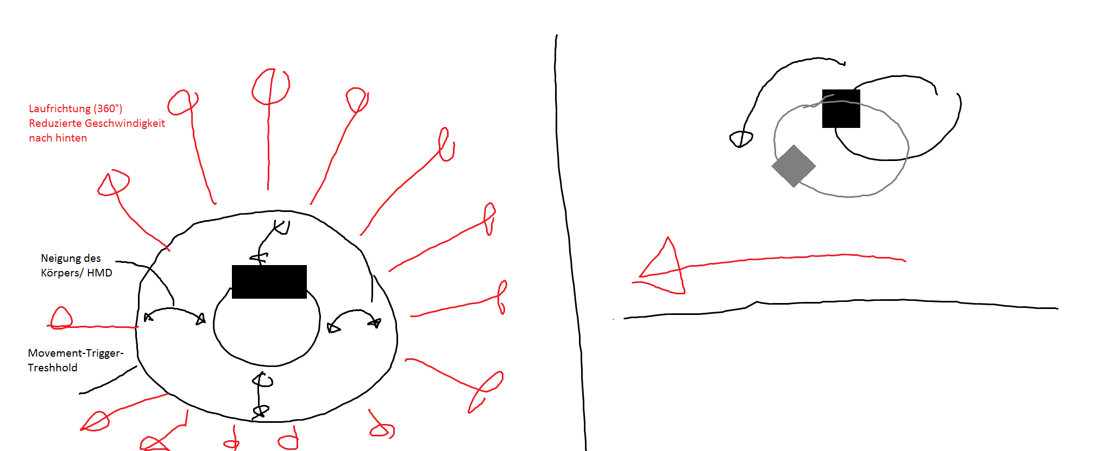

**Teleporting (T)**

* Teleporting to a selected destination
  + Blink transition

**Jumping (T)**

* Teleporting to predefined locations
  + Cross on floor, glow when reachable and selected
  + Arch transition
  + Jump in place with jumplike hand movement

